**Product Perspective**

The Room Reservation System is a single system that users interact with and uses a database to store data. Because of this, it is not a self-contained system. If for example, the system was to access school records to verify students attempting to login, and also access the school room bank to check what rooms could be reserved, then the system would be self-contained.

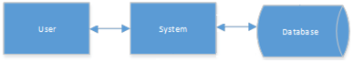

************Pretty Sure that the user should never be allowed to access the database directly, it always goes through the system. Therefore we will go with the option above and ask for feedback.

